- Student details, ie ID#, Full Name, Assignment #, Day/Time of class, Module name/Module Code.

Brittney Lobban
2406413
Assignment #2
Friday 11:00-12:50 am
Web Programming - CIT2011

- Storyboard – including wireframe, sitemap, etc.

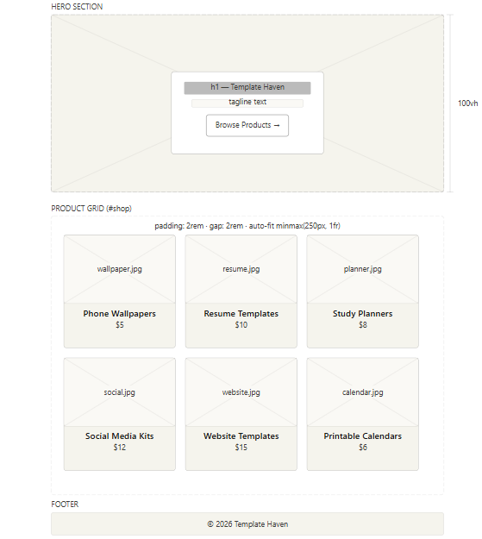
WIREFRAME

`

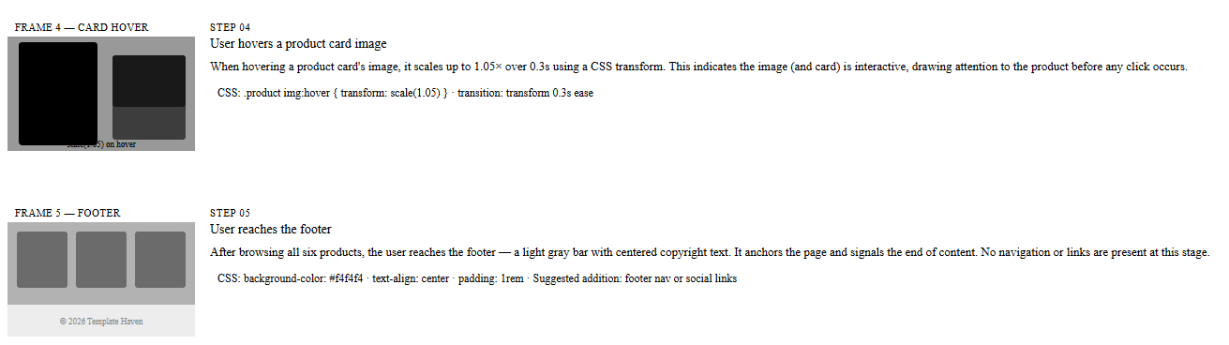
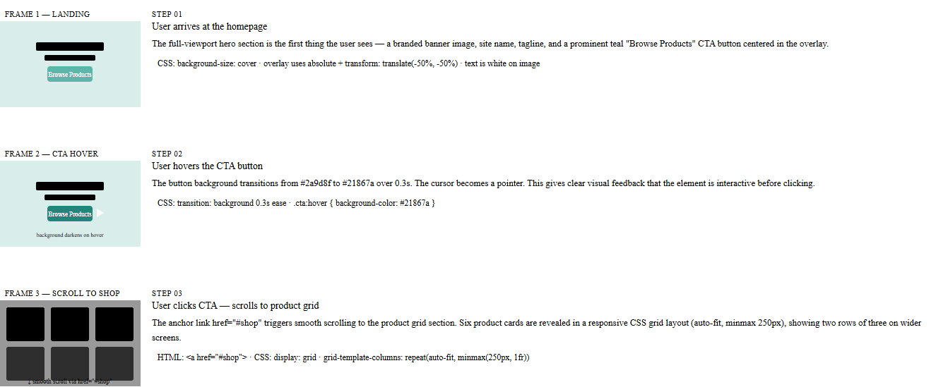
STORYBOARD

ii. A description of your business, logo, slogan, mission statement, vision, statement, etc

Business Name: Template Haven

Logo: A simple logo just a couple of overlapping rectangles in teal and orange, with a checkmark layered on top, symbolizing organization and creativity.

Slogan: “Designs that simplify your life.”

Mission Statement: At Template Haven, we're all about making digital templates affordable, stylish, and practical. We help students, professionals, and creatives get organized, save time, and show off their best work with confidence.

Vision Statement: We're aiming for Template Haven to become everyone’s go-to spot worldwide for digital resources you can use right away. We want people to have access to tools that make planning, studying, and creating feel easy.

iii: Include a brief justification of the color palette you chose for your website, ie the psychology of color in web design and marketing.
The website goes with a mix of teal (#2A9D8F), warm orange (#F4A261), beige, and dark gray. It's not just for looks—there’s some solid psychology behind these choices.
- Teal gives off trust, calm, and a sense of professionalism, which is perfect for a brand aiming for reliability and creativity.
- Orange brings the energy and enthusiasm, plus it feels affordable, so it nudges people to get involved or make a purchase.
- Beige and other neutral shades pull everything together, making things look clean and friendly.
- Dark gray keeps things readable and adds a touch of class.
The video on color psychology in marketing backs all this up. Colors shape how we feel and what we decide. By pairing teal’s trustworthy vibe with orange’s lively energy, Template Haven comes across as both credible and exciting. That mix really pushes users to dig deeper and buy digital products.
iv. Description of the intended audience for your website.
Template Haven is built for a few groups.
- Students look for planners, calendars, and resume templates to keep their lives organized and get a head start on their careers.
- Young professionals are out to craft a sharp resume or build up their brand on social media, so clean templates and social kits matter to them.
- Creatives and entrepreneurs who just need affordable website templates and solid design assets so they can launch something without a huge budget or long delays.
Everyone who comes to Template Haven has a few things in common. They want stuff that looks good, doesn’t cost a fortune, and makes their lives easier. They know their way around tech and usually juggle school, work, maybe a side hustle. Fast, professional, ready-to-go solutions are the things that really speak to them.
e. Free hosting link.
https://britt876.github.io/Template-Heaven/

References

Beige Aesthetic Floral Monthly Financial Planner – Templates by Canva. (2026). Beige aesthetic floral monthly financial planner [Template]. Canva.
https://www.canva.com/templates/EAGLY4E6KpU-beige-aesthetic-floral-monthly-financial-planner/

Canva. (2026). Brown neutral professional resume template [Template]. Canva.
. https://www.canva.com/design/DAHFRqJOxls/H-vgK6LMEKm9X21wsE7uDg/edit?referrer=https%3A%2F%2Fwww.canva.com%2Ftemplates%2FEAE5F_B9Ijs-brown-neutral-professional-resume-template%2F

Canva. (2026). Gradient pixel color palette calendar [Template]. Canva.
https://www.canva.com/design/DAHFRQy-Wag/lzQMou_4nyssyuBZxj8Teg/edit?referrer=https%3A%2F%2Fwww.canva.com%2Ftemplates%2FEAFPXIpuh3s-gradient-pixel-color-palette-calendar%2F ‌

Canva. (2026). White minimalist financial planner [Template]. Canva.
https://www.canva.com/templates/EAF6A8mv9m0-white-minimalist-financial-planner/
‌
Canva. (2026). White minimalist resume template [Template]. Canva.
https://www.canva.com/design/DAHFRgZ01Jc/2HetqjVt_D5UmGuY4ta0nw/edit?referrer=https%3A%2F%2Fwww.canva.com%2Ftemplates%2FEAFKrDDTeE0-white-minimalist-resume%2F

Canva. (2026). Website launch promotional graphic [Template]. Canva.
https://www.canva.com/design/DAHFRpqhIBI/cQ3d4PEG0bUJGkAcC9dKkA/edit

Canva. (2026). Website now live promotional graphic [Template]. Canva.
https://www.canva.com/design/DAHFRU9KJPQ/GL0sCGOKnP5Qkss-Lp00lw/edit

Canva. (2026). Special treatment beauty ad [Template]. Canva.
https://www.canva.com/design/DAHFRRiyp8w/2wwz3omhmYi_dJtasCOIYA/edit

Canva. (2026). Food plating promotional ad [Template]. Canva.
https://www.canva.com/design/DAHFRavkS-8/gcvLkBYnf_CdWoxpmkbZDg/edit

Canva. (2024). Grey minimal 2024 calendar document [Template]. Canva.
https://www.canva.com/design/DAHFRRoBRm8/nVcLq6mlV41rmKox2rvriQ/edit?referrer=https%3A%2F%2Fwww.canva.com%2Ftemplates%2FEAFy_V6_xfo-grey-minimal-2024-calender-document%2F

Envato. (2021, March 18). Color Psychology | Red, blue, yellow, green, pink, white, black, gray and gold [Video]. YouTube. https://www.youtube.com/watch?v=8J0nbuunDXc

Wu, T. (2026, March 23). A delicate pink magnolia flower blooms on a branch
https://unsplash.com/photos/a-delicate-pink-magnolia-flower-blooms-on-a-branch-TzKBCfzQ2WI

